ENTRY METHOD: FIRST RECEIVED
Entries will close on Day of Trial. Overnight or certified mail must be sent with the “No Signature Required” waiver signed. DAY OF TEST ENTRIES WILL BE ACCEPTED IF LIMITS NOT MET.
ENTRIES CLOSE ON DAY OF TRIAL after which time entries cannot be accepted, cancelled, altered, or substituted except as provided for in Chapter 11, Section 6 of the Rules Applying to Dog Shows. Envelopes/transactions containing entries for more than the six (6) dog maximum and/or entries received prior to the opening date shall be treated as an invalid entry and shall be returned to the sender.

Premium List
Leonberger Club of Texas

(
Licensed by the American Kennel Club

AKC Temperament Test
July 16, 2026 - Two Trials
July 17, 2026 - Two Trials
July 18, 2026 - Two Trials
July 19, 2026 - Two Trials
Hosted by Leonberger Club of Texas
July 16, 2026 Event #2026775017 July 16, 2026 Event #2026775018
July 17, 2026 Event #2026775019 July 17, 2026 Event #2026775020
July 18, 2026 Event #2026775021 July 18, 2026 Event #2026775022
July 19, 2026 Event #2026775023 July 19, 2026 Event #2026775024
_______________________________________________________
NRG Houston World Series of Dog Shows
NRG Center
1 NRG Park
Houston, TX 77054
ENTRY LIMITS
40
Trial Hours:
Trial 1: 9:30 am Trial 2: To follow Trial 1 (competitors will be able to go through Trial 1 and then Trial 2 consecutively
to make best use of time)
Building opens at 6:00 am
Day of Trial entries accepted from 9:00 am – 3:00 pm
ATT Evaluators:
Amy Sheehan
Ruth Dillman
Deanna England
Althea Gibson (Alternate)
**CANINE PARTNERS (Mixed Breeds) Welcome**

CERTIFICATION

Permission is granted by the
American Kennel Club for the holding
of this event under American Kennel Club rules and regulations.

Gina DiNardo, Secretary

OFFICERS OF Leonberger Club of Texas
President ………………………………………………………….….Wendy Jones
Vice President …………………………………………….….….…..Arlene Adrian Secretary……………………………………………………….…Ashley Donohue
Treasurer………………………………………… ……...…….... Amy Frank
EVENT COMMITTEE
Ashley Donohue, Judy Walter, Grant Johnston, Arlene Adrian, Wendy Jones and other members of the club
EMERGENCY VETERINARIAN
24/7
BluePearl Pet Hospital
3800 Southwest Frwy., Ste. 136
Houston, TX 77027
(713) 999-9538
EMERGENCY SERVICES
Fire/ Ambulance/Police- Harris County – 911
Houston Methodist Hospital
6565 Fannin St, Houston, TX 77030 (713) 790-3311
ENTRY FEES
Each entry*……..$30
*An entry is defined as a single run by a single dog.
Mail entry forms and fees to:
Althea Gibson
2710 Weald Way Ct Spring, TX 77388
Please make checks payable to LCoT.
Online entry option is now available via this link: https://www.leonbergercluboftexas.com/nrg-att-cgcs-and-tks-form
Convenience fees will be added and those fees are non-refundable.
No entries will be accepted by phone, email, or fax. Express mail entries must include the signature waiver allowing them to be left at the secretary’s address. Inquiries may be directed to Althea Gibson at sportsdogs@yahoo.com. No entry shall be made and no entry shall be accepted which specifies any conditions as to its acceptance. Returned checks do not constitute a valid entry. The Trial Secretary will add a $40.00 collection fee to the amount of each returned check.
DIRECTIONS TO THE TRIAL SITE
Please use your favorite GPS app to get directions to:
NRG Center
1 NRG Park
Houston, TX 77054
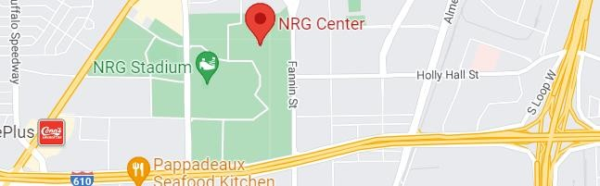
OFFICIAL AKC ATT ENTRY FORM
Please check the box for each test desired to be entered.
Send entries to: | Make checks payable to: LCoT
Althea Gibson  RE: Houston ATT  2710 Weald Way Ct.  Spring, TX 77388 | Trial Secretary will add a $40.00 fee to the amount for each returned check
# of test entered: __________ x $30.00 = $ ________________ Total Due
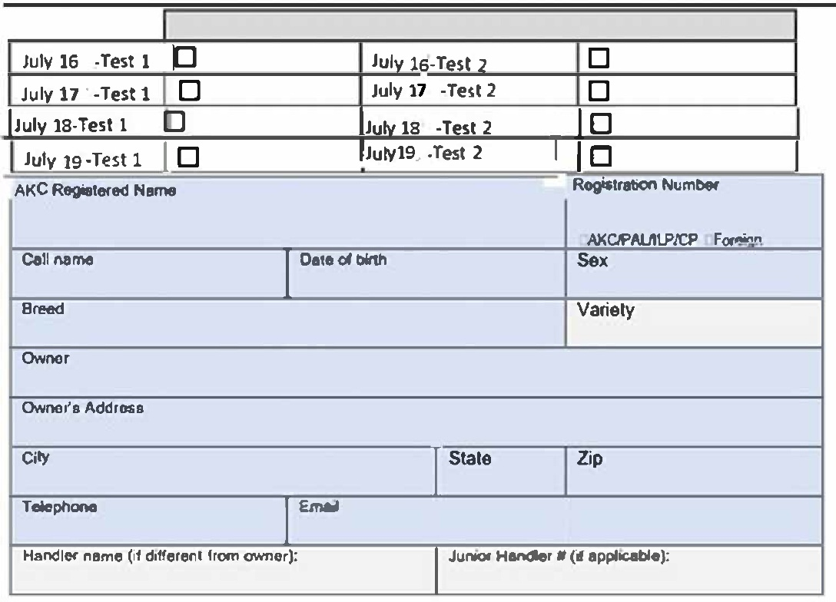
Fields marked in blue are REQUIRED.
Fields marked in gray must be completed if the information is known. **Be sure to read the agreement and sign below. **
***No form will be processed without your signature!***

AKC Rules, Regulations, Policies and Guidelines are available on the American Kennel Club
Web site,
www.akc.org

AGREEMENT

I certify that I am the actual owner of the dog, or that I am the duly authorized agent of the actual owner whose name I have entered. In consideration of the acceptance of this entry, I (we) agree to abide by the rules and regulations of The American Kennel Club in effect at the time of this event, and any additional rules and regulations appearing in the premium list of this event and entry form and any decision made in accord with them. I (we) agree that the club holding this event has the right to refuse this entry for cause which the club shall deem sufficient. I (we) certify and represent that the dog entered is not a hazard to persons or other dogs. In consideration of the acceptance of this entry and of the holding of this event and of the opportunity to have the dog judged and to win prizes, ribbons, or trophies, I (we) agree to hold the AKC, the event-giving club, their members, directors, governors, officers, agents, superintendents or event secretary and the owner and/or lessor of the premises and any provider of services that are necessary to hold this event and any employees or volunteers of the aforementioned parties, and any AKC approved judge, judging at this event, harmless from any claim for loss or injury which may be alleged to have been caused directly or indirectly to any person or thing by the act of this dog while in or about the event premises or grounds or near any entrance thereto, and I (we) personally assume all responsibility and liability for any such claim; and I (we) further agree to hold the aforementioned parties harmless from any claim of loss, injury or damage to this dog.

Additionally, I (we) hereby assume the sole responsibility for and agree to indemnify, defend and save the aforementioned parties harmless from any and all loss and expense (including legal fees) by reason of the liability imposed by law upon any of the aforementioned parties for damage because of bodily injuries, including death at any time resulting therefrom, sustained by any person or persons, including myself (ourselves), or on account of damage to property, arising out of or in consequence of my (our) participation in this event, however such, injuries death or property damage may be caused, and whether or not the same may have been caused or may be alleged to have been caused by the negligence of the aforementioned parties or any of their employees, agents, or any other person. I (we) agree that the determination of whether the injury is serious shall be made by the event veterinarian and is binding on me (us). I (WE) AGREE THAT ANY CAUSE OF ACTION,
CONTROVERSY OR CLAIM ARISING OUT OF OR RELATED TO THE ENTRY, EXHIBITION OR ATTENDANCE AT THE EVENT BETWEEN THE AKC AND THE EVENT-GIVING CLUB (UNLESS
OTHERWISE STATED IN THIS PREMIUM LIST) AND MYSELF (OURSELVES) OR AS TO THE
CONSTRUCTION, INTERPRETATION AND EFFECT OF THIS AGREEMENT SHALL BE SETTLED BY ARBITRATION PURSUANT TO THE APPLICABLE RULES OF THE AMERICAN ARBITRATION ASSOCIATION. HOWEVER, PRIOR TO ARBITRATION ALL APPLICABLE AKC BYLAWS, RULES,
REGULATIONS, AND PROCEDURES MUST FIRST BE FOLLOWED AS SET FORTH IN THE AKC CHARTER AND BYLAWS, RULES, REGULATIONS, PUBLISHED POLICIES AND GUIDELINES.

SIGNATURE of owner or his agent duly authorized to make this entry.

SIGN HERE X:________________________________________________________________

Phone #:_____________________________________________________________________

Email: ______________________________________________________________________

In case of Emergency – Name: _________________________ Phone # _________________

